Dear BNI Business Connections Visitor

We are very pleased that you will be attending one of our weekly BNI meetings. The following information should help you get the most from your attendance!

Meeting Date/Time:  Every Thursday from 7:00 am – 8:30 am (Networking starts at 6:45 am)  The Osher Marin JCC  200 N. San Pedro Rd.  San Rafael, CA 94903  Link to Map | 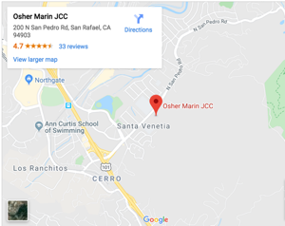

Meeting Details:
- The best connections with potential referral sources happen BEFORE and AFTER the meeting. Please plan to arrive by 7:00 and stay a few minutes after.
- Be sure to bring 50 business cards to share with our members.
- Buffet breakfast is complimentary. We have a full cooked breakfast, complete with fruit, yogurt, eggs, pastries, coffee and tea.
- During the meeting you'll be able to hear our members’ 30-second infomercials to find out who we are, what we do and how we can add value to your business. Although you won’t be able to give your own infomercial, our President will introduce you and what you do.
- BNI allows one member per business category. There may be a niche within a particular category that you could occupy. For example, the category of insurance has several market niches.
- If your category overlaps the category and market niche of one of our current members, unfortunately, we won’t be able to hand out your business cards. If you are interested in our group, we are happy to put you on our waiting list.
- After the meeting, our BNI Visitor Hosts will meet with you to answer any questions that you may have.
- You're always welcome to contact any of our officers for more information:

BNI Business Connections Leadership Team.

